| **Test Name** | | | Exception Test-Server | | | |
| --- | --- | --- | --- | --- | --- | --- |
| **Use Case Tested:** | | | All Use Cases-Server not Available error | | | |
| **Test Description:** | | | When a user try’s to play the game without internet the application should let them know by displaying an error that the server is unavailable | | | |
| **Pre-conditions** | | | Application must be open | | | |
| **Post-conditions** | | | An error should be displayed on the screen alerting them that they can’t reach the server | | | |
| **Notes:** | |  | | | | |
| **Result (Pass/Fail/Warning/Incomplete)** | | **Pass** | | | | |
|  | **TEST STEP** | | | **EXPECTED TEST RESULTS** | P | F |
|  | Game try’s to connect to server | | | That a warning be displayed asking There was an error connecting to the server. Do you wish to retry | P |  |

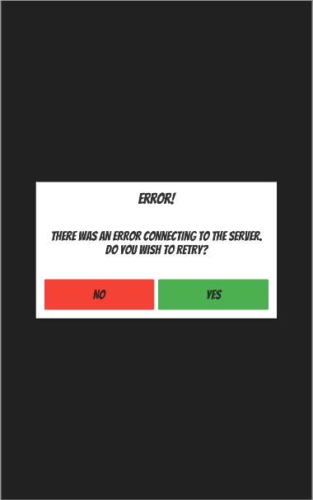

Error displayed asking user if they wish to try again